Requirements for New Individuals to the IPSIDD/INDEPENDENT Program:

- Life Plan (most recent existing on file.)
- Last psychological and psychosocial evals (if requesting psychology)
- Last semi & annual medical exam (if requesting nutrition)
- If Medicaid or Medicare, only provide the Medicaid number. That’s all we need. We run an ePaces MEVS check!
- If duals advantage or BCBS, or Fidelis, etc. then we will need front and back of current card(s)
- Scripts: May be procured from the NP Visits practice or the PCP of the consumer. NT, OT and PT scripts are mandatory. Cognitive psychology and speech therapy scripts are optional.

~~~~~~~~~~~~~~~~~~~~~~~~~~~~~~~~~~~~~~~~~~~~~~~~~~~~~~~~~~~~ Multi Practitioner’s Group statement:
We would appreciate the prompt completion of this packet. Please fax or mail items immediately to the assigned Intake Coordinator.

Name of Group | - The Caring PT Group, PLLC  - Caring, SLP, Psychology, OT & Nutrition Services, PLLC  - NP Family Health Visits & NP Adult Health Visits, PLLC
Attn: | Yvonne Pasqualicchio, Group Director
Address | 17 North Plank Road, Suite 10
Address | Newburgh, NY 12550
Phone | 845-800-9305
Fax | 844-800-1470
Email | Email: yvonnep@selectmulticare.com
website | www.selectmulticare.com

Revised 08.08.25. CTS

IPSIDD/INDEPENDENT SERVICES REFERRAL FACE SHEET

Name (last, first)
DOB:
SSN:
Medicaid #
Medicare # (optional)
Other Ins. (send copy of front and back
of card)
Full address of Treatment Location. (Specify: Group Home, Private Home,
Day Hab, Other)
Treatment Location Contact’s
Name/Relationship
Contact’s best phone #
Contact’s email
Name, email, phone of Care Manager.
(Specify which CCO)
Referred to IPSIDD program for: □ OT Occupational Therapy | To improve impaired fine motor skills, upper extremity strength, ameliorate cognitive impairments (via ADLs, money management)
Referred to IPSIDD program for: □ PT Physical Therapy | To increase endurance to gait, ambulation, stair climbing, wheelchair/walker management, upper and lower body strength
Referred to IPSIDD program for: □ ST Speech Therapy | Ameliorate effects of expressive and receptive language disorders, swallowing disorders, sign language to indicate needs and wants
Referred to IPSIDD program for: □ Psy Psychotherapy/Counseling | 1:1 - Cognitive psychotherapy based on Treatment Plan drawn up with input from staff, team and client; Behavior Plans
Logical+Social/Adaptive+Cognitive □ | Psychological + Psychosocial evaluations being requested
Nutrition/Eating Disorders □ | Meal Plans; Menu’s, Recipes, LifeStyle Coaches, kitchen skills
eMod. vMod. Wheelchairs. DMEs. □ | Clinical Justifications provided by skilled clinicians

CONSENT/RELEASE STATEMENT

I am consenting to receive IPSIDD/Independent clinical services from the above Multi Practitioner Groups. I authorize any holder of medical information about me to release to the Group’s Claims Administrators any information needed to determine these benefits or the benefits payable for related services.

- Individual is unable to sign. Responsible party is completing the below on individual’s behalf
Name of Individual or Representative
Title/Relationship to individual
Signature
Date of consent

Revised 08.08.25. CTS

1

Receive intake from the site
The Diabetes Prevention & Nutrition Program
Brought to you by: Caring Therapy Services!
(via your own HIPAA compliant portal that we create for you)

2

Intake should include the latest annual & semi ME
3

Evaluating RD will also need the latest height and weight of the Individual
4

6

Site Nurse and Staﬀ – be sure to watch out for Cooking Classes video’s!

5

LifeStyle Coaches check in with site twice a month
- Beginning of the month to populate Weight & Wellness Grids
and get feedback
- Middle of the month to deliver Nutrition Guidance Packets

Evaluating RD will call the site to interview Site Manager & Site Nurse



























By working together we will make it work!

You tel I us whom is need of a new or a re-newed wheelchair

Our Nurse Practitioners will issue the order for the WC

We will come to your home or group home to do the measurements. We gladly accept staff and patient's input. After all, you are the ones using and assisting the use of this wonderful new WC

We are in liaison with a trustworthy WC vendor who will be accompanying us on day 2 of the assessment and report

•••••••••
•• • • •
After the WC arrives at your home, our Nurse Practitioners will conduct a post-delivery Q&A

9 ENJOY YOUR NEW CHAIR!

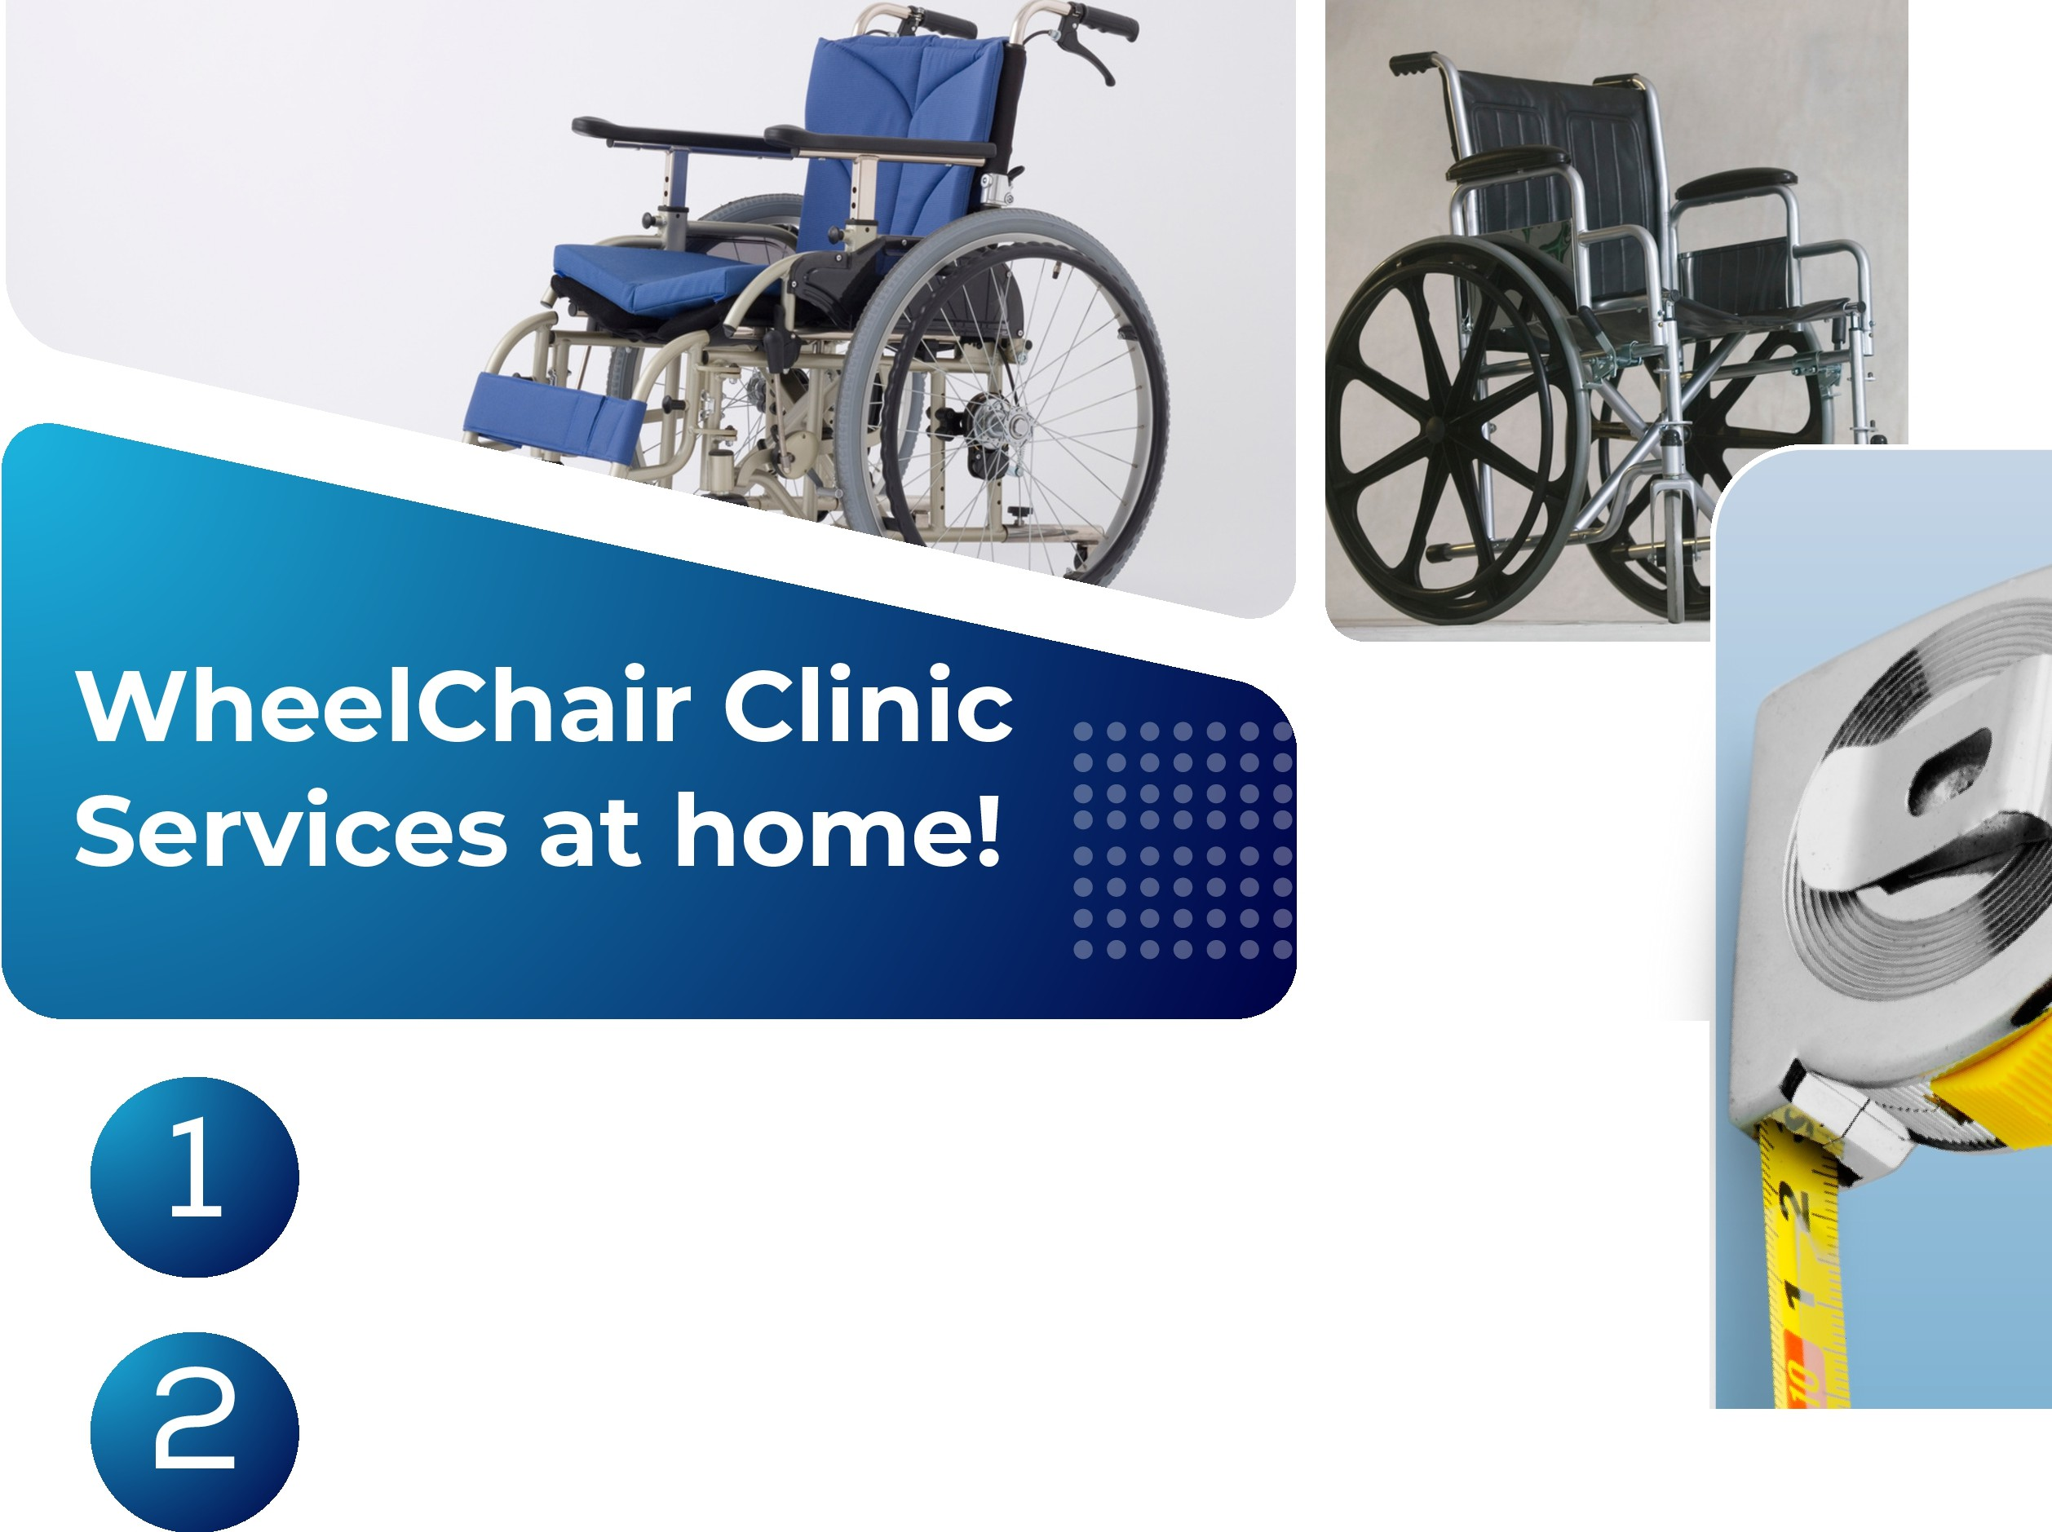



• •
I
t
I•

GROUP HOME CASELOAD GRID
Res Mgr |  | Multi Prac Group | Caring Therapy Services, PLLC
Phone |  | Community Agency
Fax |  | Group Home Address
Alt/Addt’l Contact |  | Email for site contact

INDIVIDUAL (Last, First name) | MEDICAID # | Speech  Therapy | Physical  Therapy | Occupational  Therapy | Psychotherapy  (Treatment Plans; Behavior Plans) | Nutrition  (Diabetes; Eating disorders; Prader-Willi) | eMod. vMod.  WheelChair. Other DME clinical justification
Doe, Sample | AA22222B | X | X | X | X | X | X
***The referrals here were agreed upon by the CareTaking Team of the Group Home***
Comments:

